Prototype-Midterm

 

|  |  |
| --- | --- |
| **Student Name/ID Number:** | Muhammad Kemal |
| **Academic Year:** | 2023 |
| **Unit Assessor:** | Arvinder kaur |
| **Project Title:** | CPL-Midterm |
| **Issue Date:** | 16 September , 2023 |
| **Submission Date:** |  |
| **Internal Verifier Name:** |  |
| **Date:** | 13 September, 2023 |

|  |
| --- |
| **Learner declaration** |
| I certify that the work submitted for this assignment is my own and research sources are fully acknowledged.  13 September  Student signature:  Date: |

1. **A summary of the project's objectives, scope, and requirements, as outlined in the project brief or proposal.**

The project, titled "Enhancing Features and Revitalizing Jumpstart Website to Fit Post-COVID-19 User Preferences," aims to strategically improve Jumpstart's website to align with shifting user preferences in the post-COVID-19 era. This comprehensive initiative includes the implementation of a new software system, seamless data migration, user training and support, and a plan for system maintenance and upgrades. The proposed system is designed to boost inventory management accuracy, expedite data retrieval, reduce manual data entry efforts, and elevate the overall quality of customer service. The project's success hinges on a comprehensive understanding of Jumpstart's current web infrastructure and thorough testing and evaluation of the proposed solutions to ensure their efficacy in meeting post-pandemic user expectations.

1. **A brief description of the technologies, programming languages, and frameworks used to develop the website.**

The website was developed using WordPress hosted on the Pantheon platform and integrated with a MySQL database. WordPress served as the Content Management System (CMS), providing a user-friendly interface for content creation and management. Pantheon offered a robust hosting environment with features like automatic scaling and high availability to ensure the website's reliability. MySQL was utilized as the database management system to efficiently store and retrieve data. Additionally, various web technologies, including HTML, CSS, JavaScript, and PHP, were employed to customize and enhance the website's functionality and design. These technologies, in conjunction with WordPress and MySQL, facilitated the creation of a dynamic and responsive website tailored to the project's requirements.

1. **Design and other design assets that illustrate the website's layout, color scheme, typography, and overall user interface design.**

Home Page

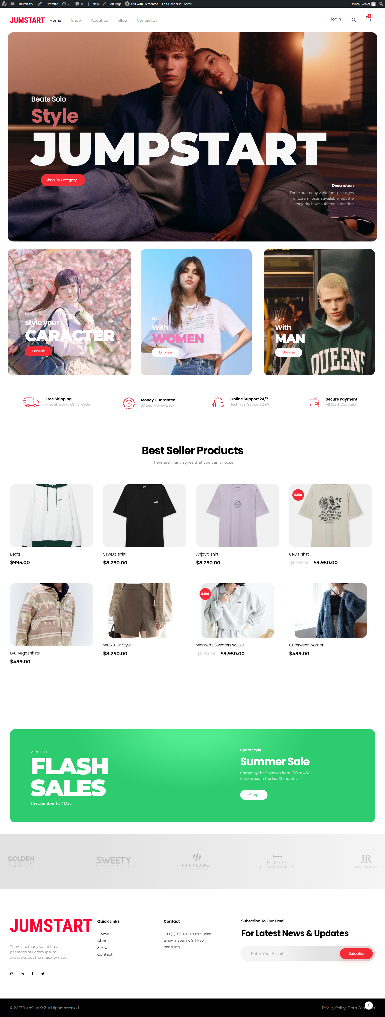

About

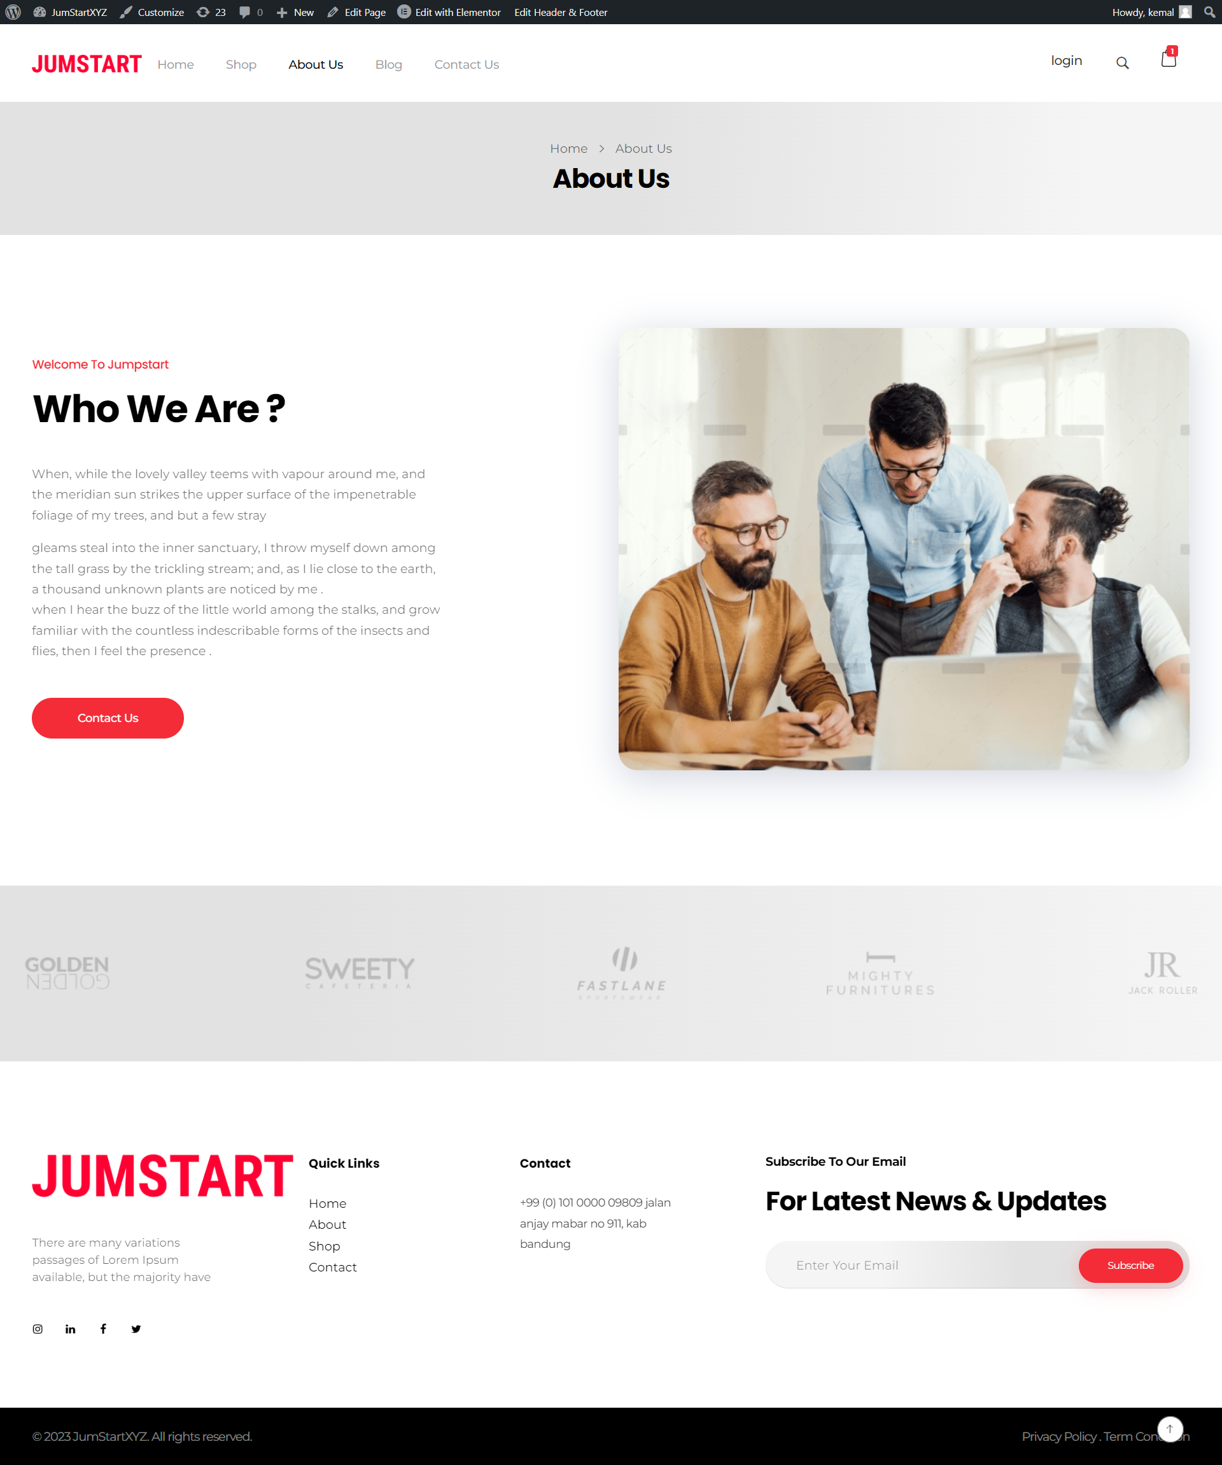

Contact Us Page

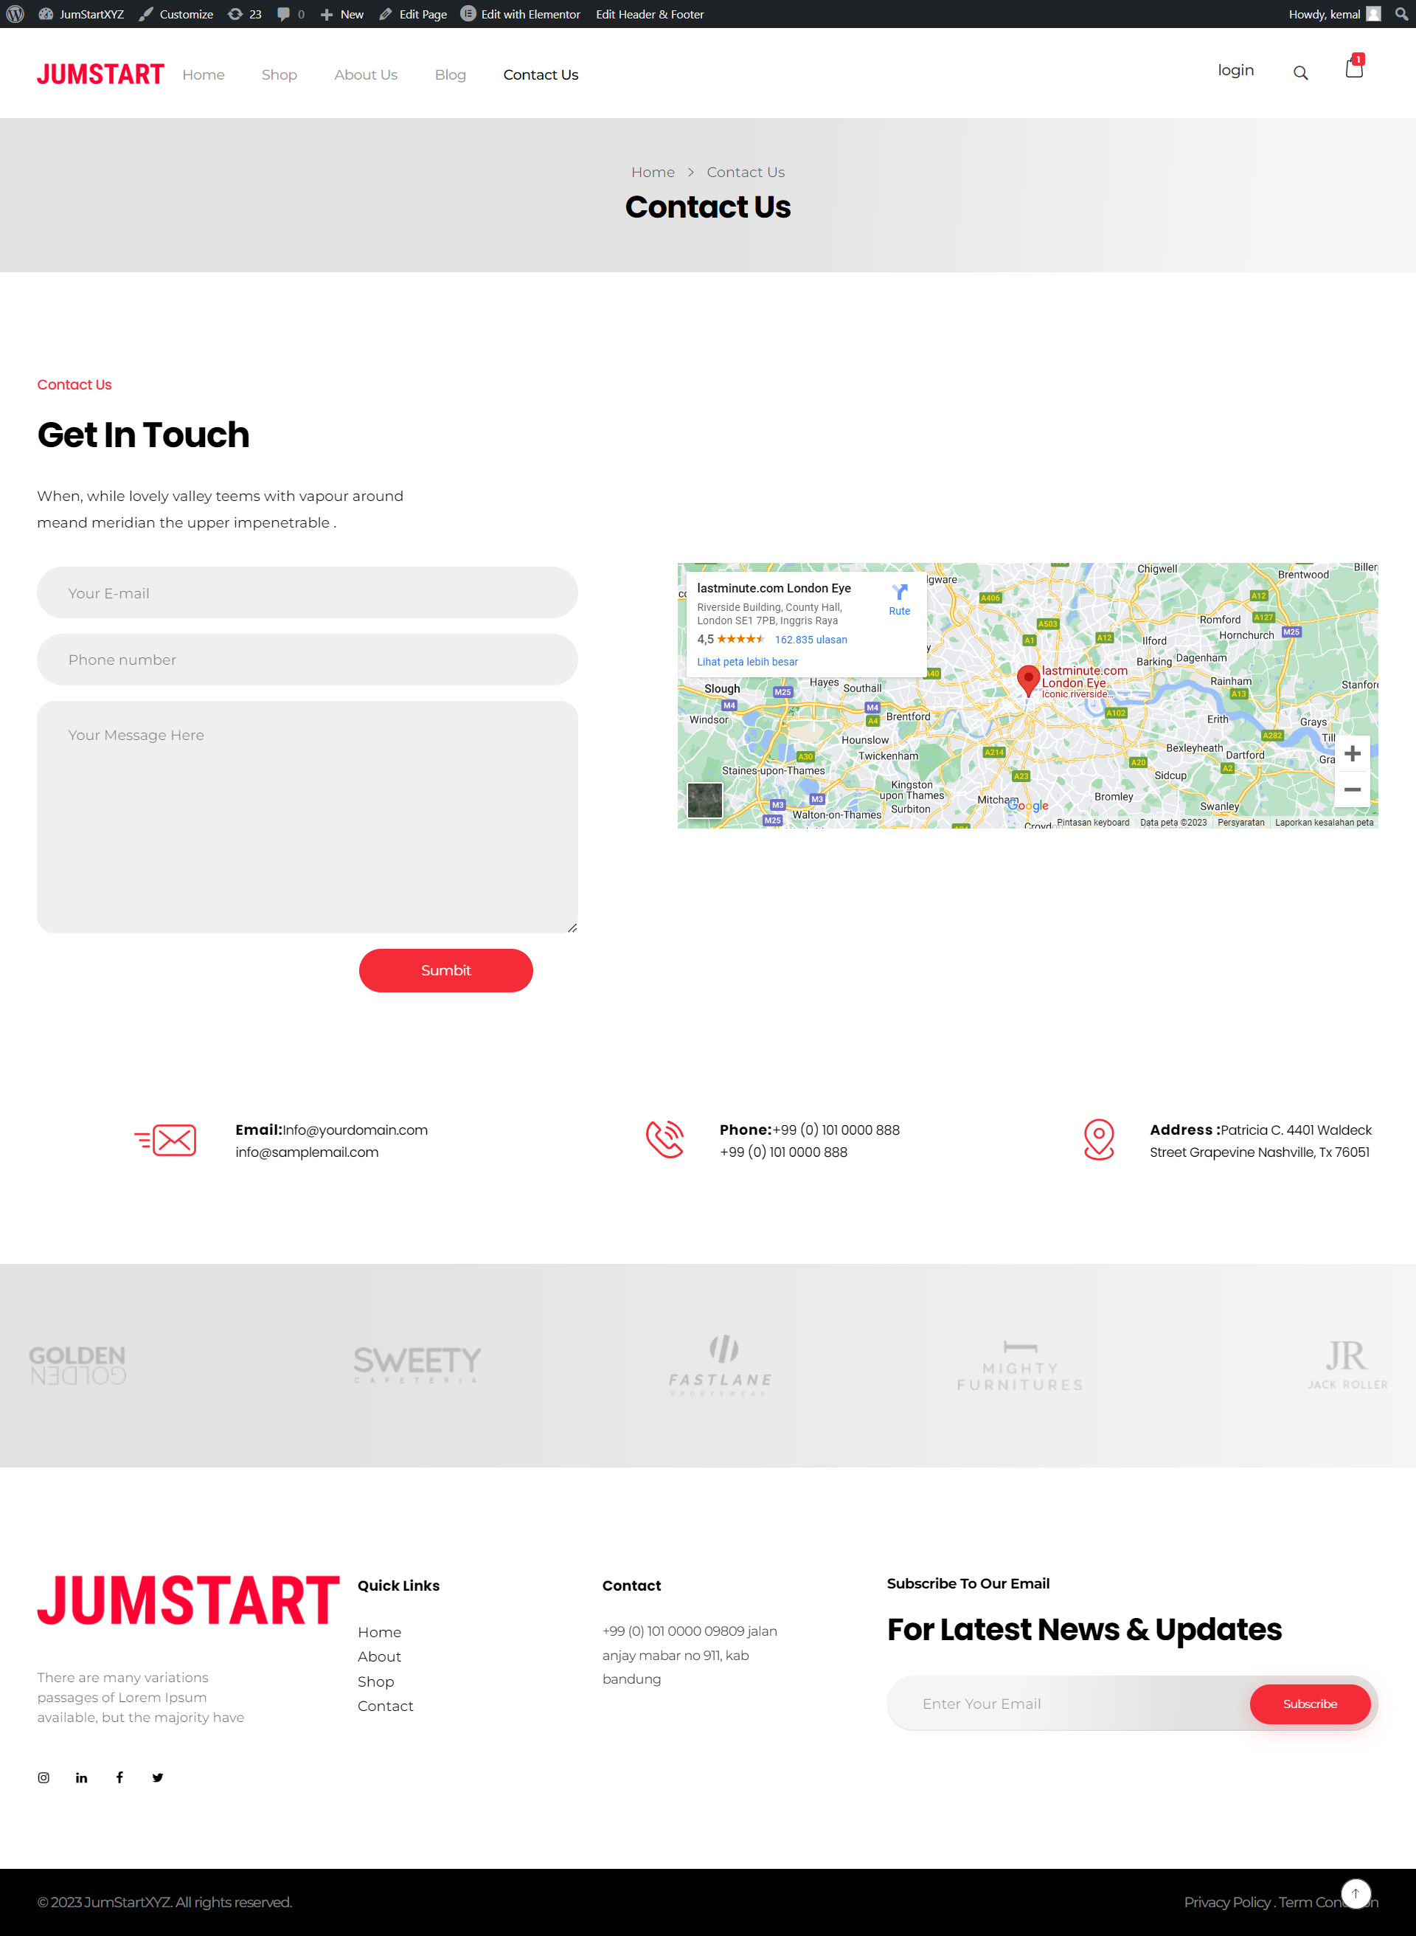

Login

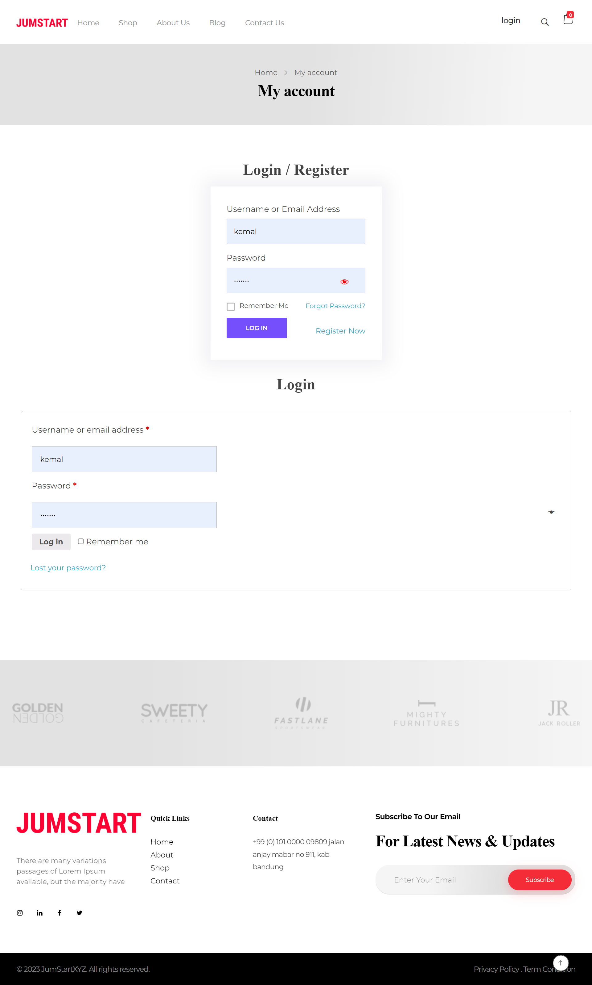

Register

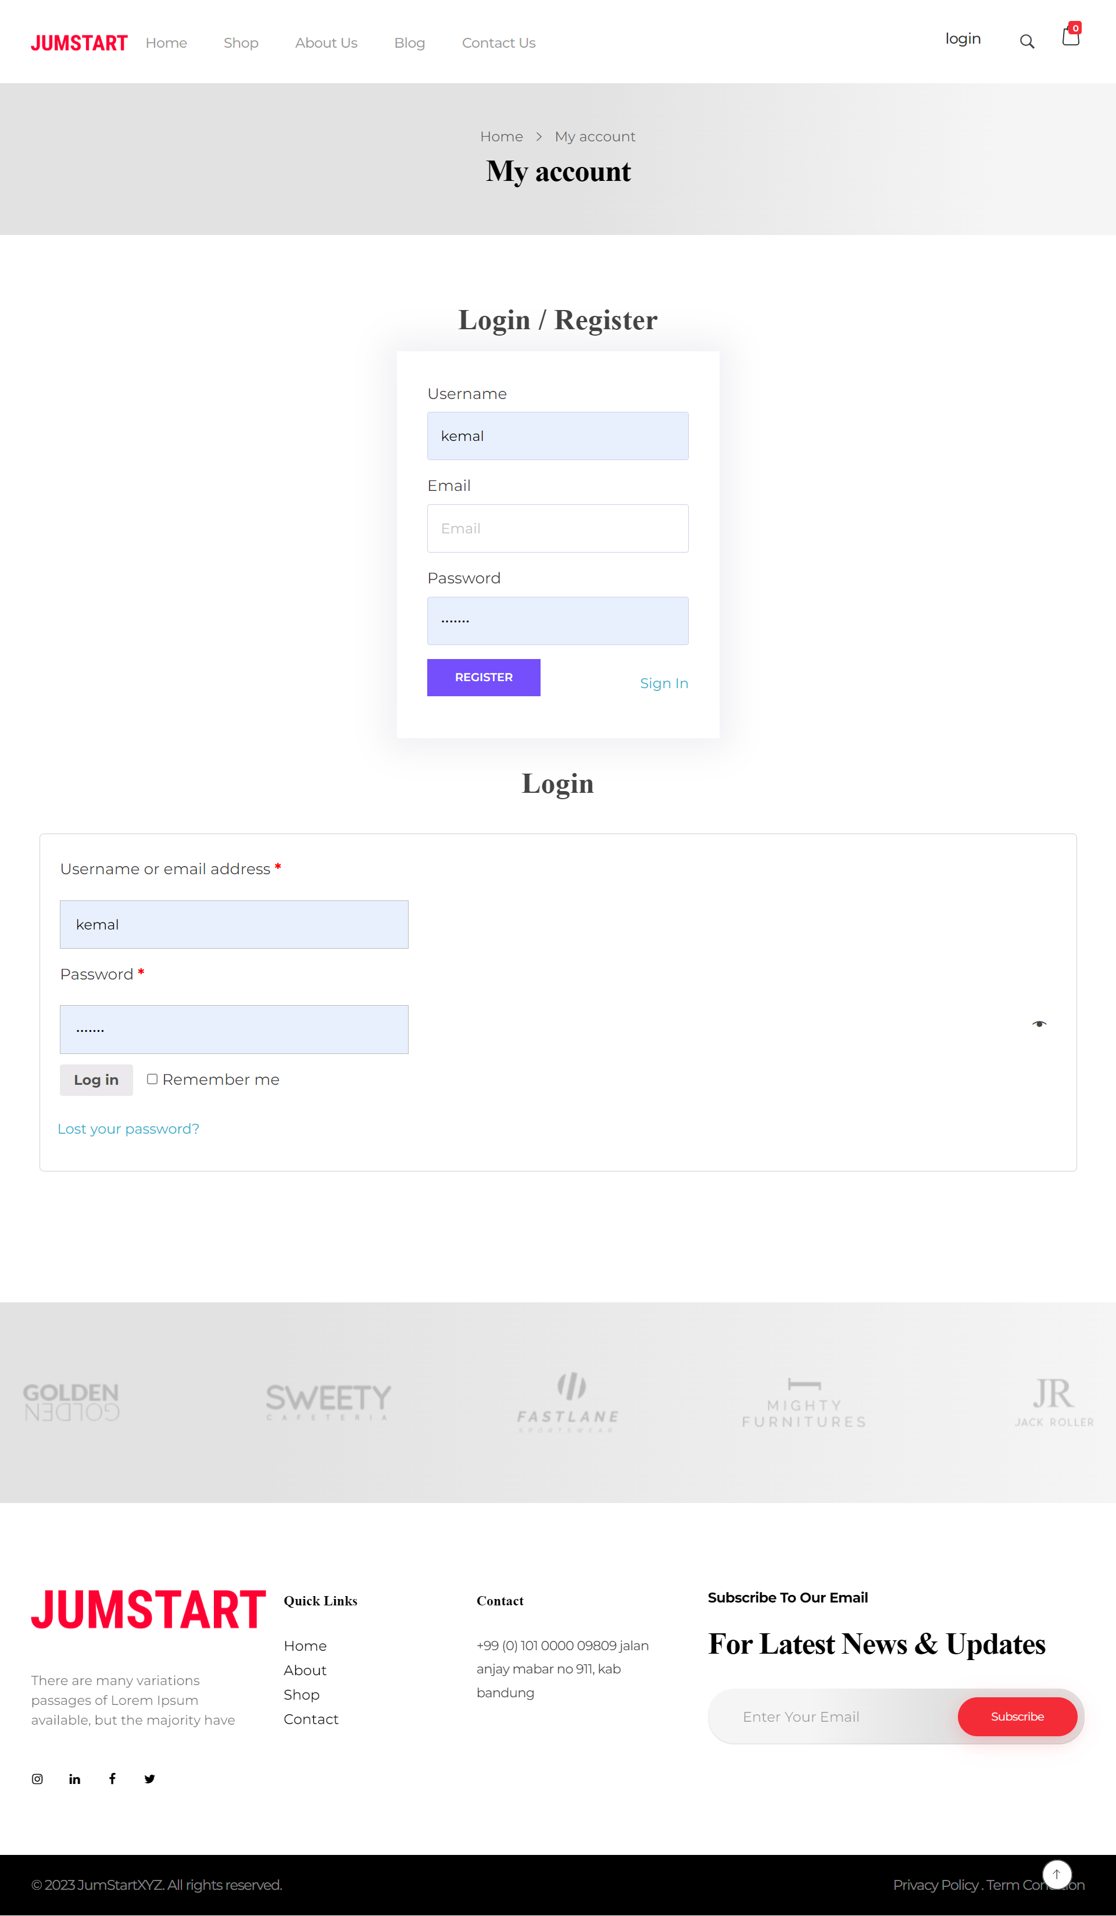

Product List

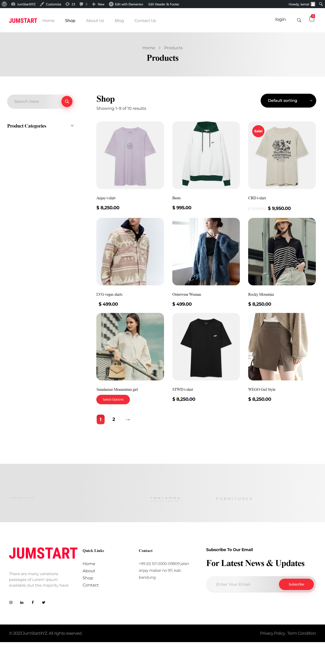

1. **A description of the website's core functionality and features that have been implemented so far, along with any that are planned for the remaining development period.**

Feature that have been implemented :

* Register: Users can open a new account on the e-commerce platform using this functionality. The user can enter personal data such their name, email address, and password. They can access their account once they have successfully registered.
* Login: Users who have registered can utilize this feature to log into their accounts by providing their email address or previously registered username and password. This enables access to exclusive areas and account-related features.
* Product List: Users can view a list of the products that are offered on the e-commerce site using this function. Every item typically has an image, a description, a price, and a button to add it to the shopping basket.
* Product List Category: Users can browse products based on certain categories thanks to this functionality. The app will then show a list of products according to that category when users choose categories based on products for men, women, and accessories.
* Add To Cart: Users can utilize this option to add their chosen products to their shopping cart. Before adding items to the cart, users can choose how many of each item they want to buy.
* Add Product - Admin: The e-commerce platform's administrators or store owners can add new products using this capability. The administrator will enter the product's name, description, picture, price, and any other pertinent data. As a result, product inventories can be added to and managed effectively.
* Checkout: The user can move on to the checkout procedure after choosing the items they want to buy and adding them to their cart. This procedure entails entering delivery details, choosing a payment option, and confirming the order before completing the transaction..
* Logout: This feature allows users to log out of their account when they have finished shopping or want to leave the platform. This is an important step to keep the user account secure.

Feature to be implemented

* Choose a Shoe Size: If you offer shoes or other items in various sizes, this option is particularly useful. Before adding the item to the cart, users can select the size that meets their preferences..
* Manage Customer/User - Admin: With the help of this feature, administrators or store owners can control user or customer information stored on the online shopping platform. Administrators can manage client data generally, set access rights, and see and change customer profile information.
* Manage Product - Admin: Administrators can manage products on the e-commerce platform thanks to this capability. Product categories can be managed, stock information updated, prices and product descriptions changed, and products added, edited, or deleted by administrators.
* Manage Order - Admin: Administrators can handle customer orders using this capability. Administrators can confirm orders, process shipments, monitor a list of incoming orders, and manage order status up until completion. This facilitates quickly tracking and completing orders.

1. **Sample code snippets and database schemas that showcase the website's back-end functionality.**

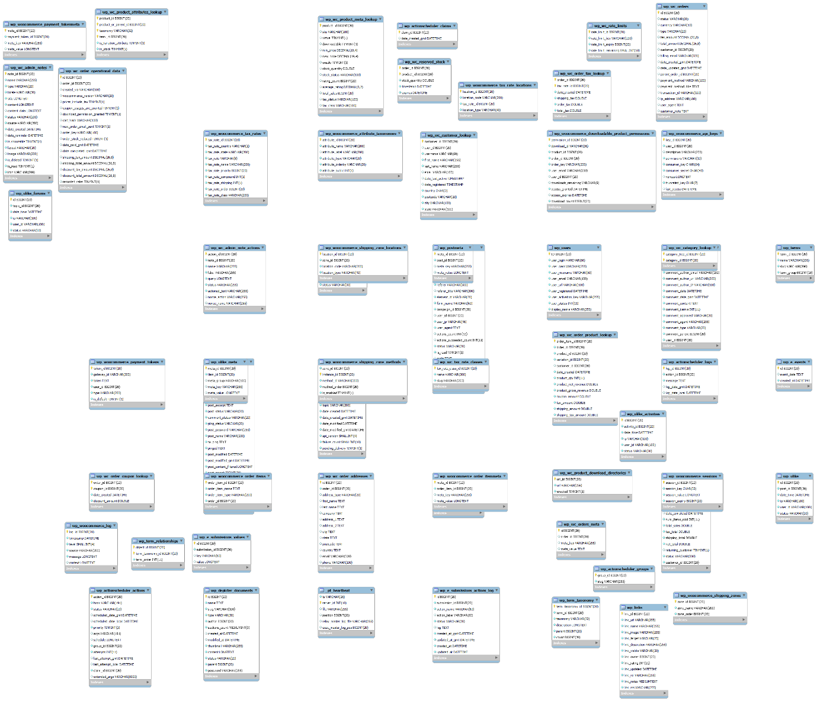

Index.php

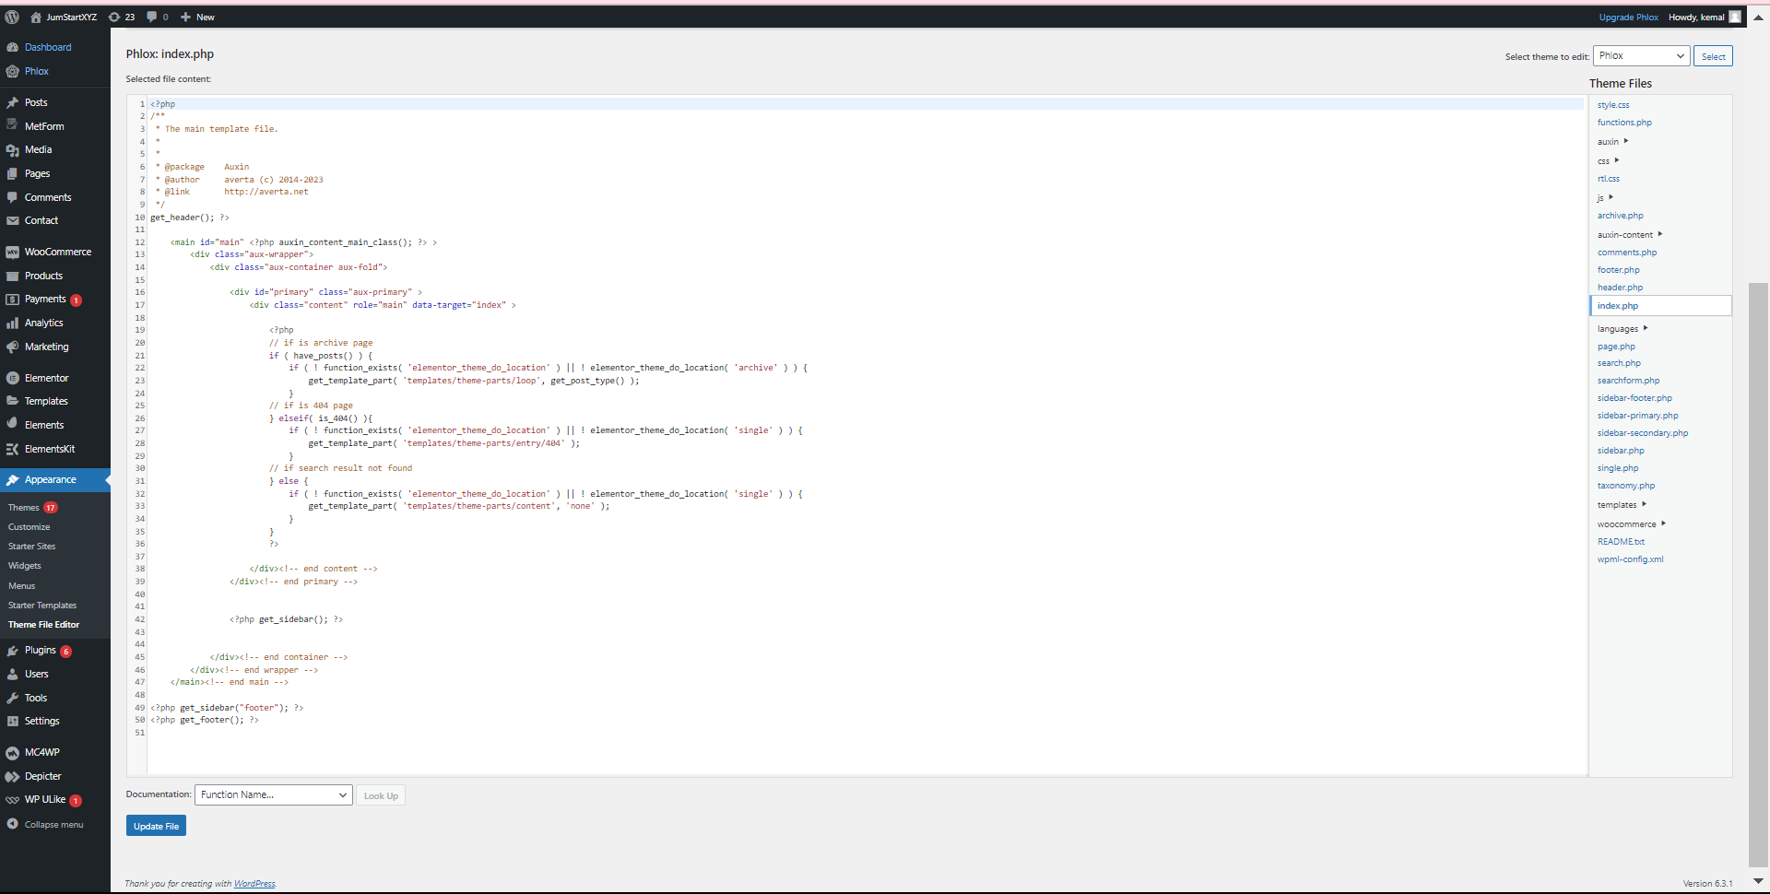

Header.php

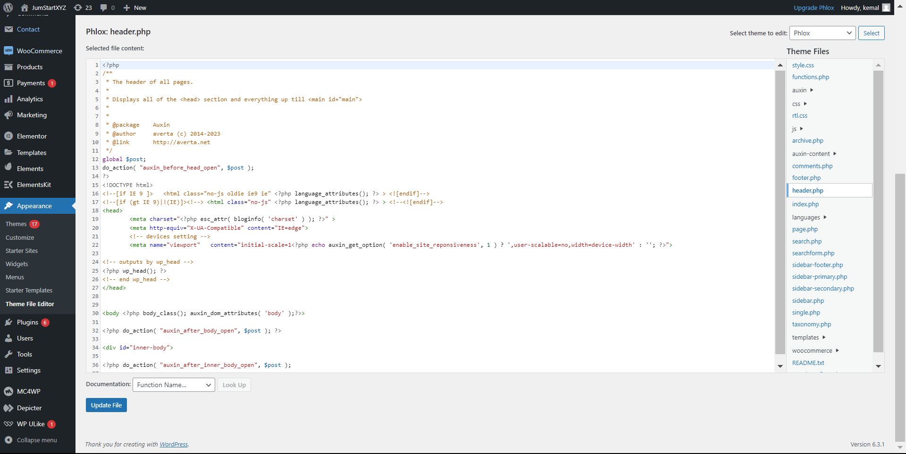

Coments.php

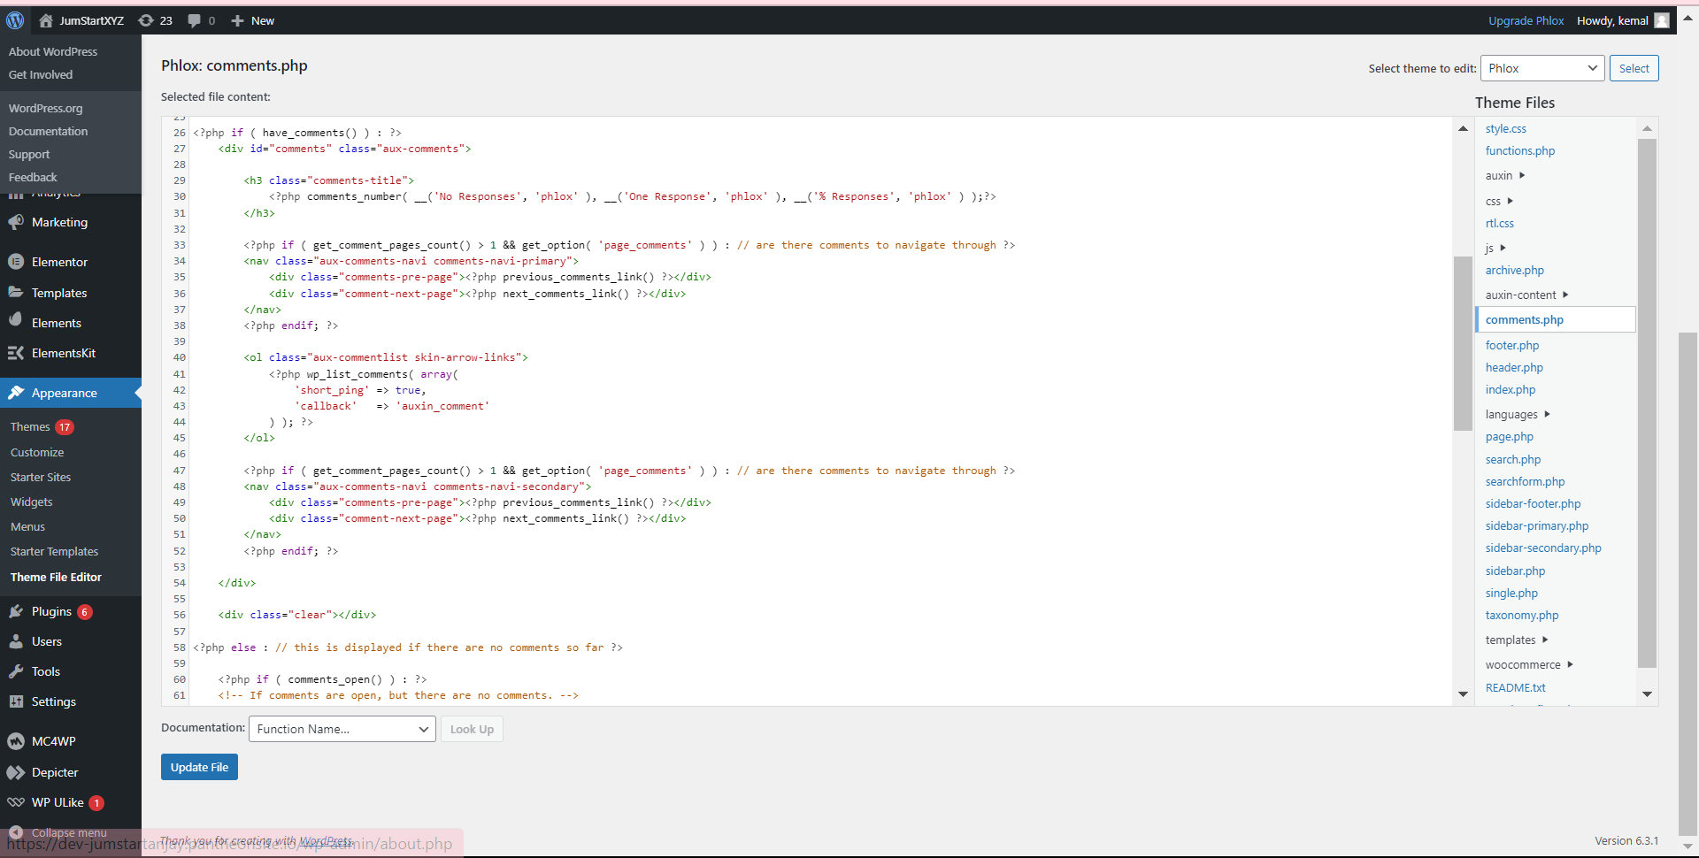

Search.php 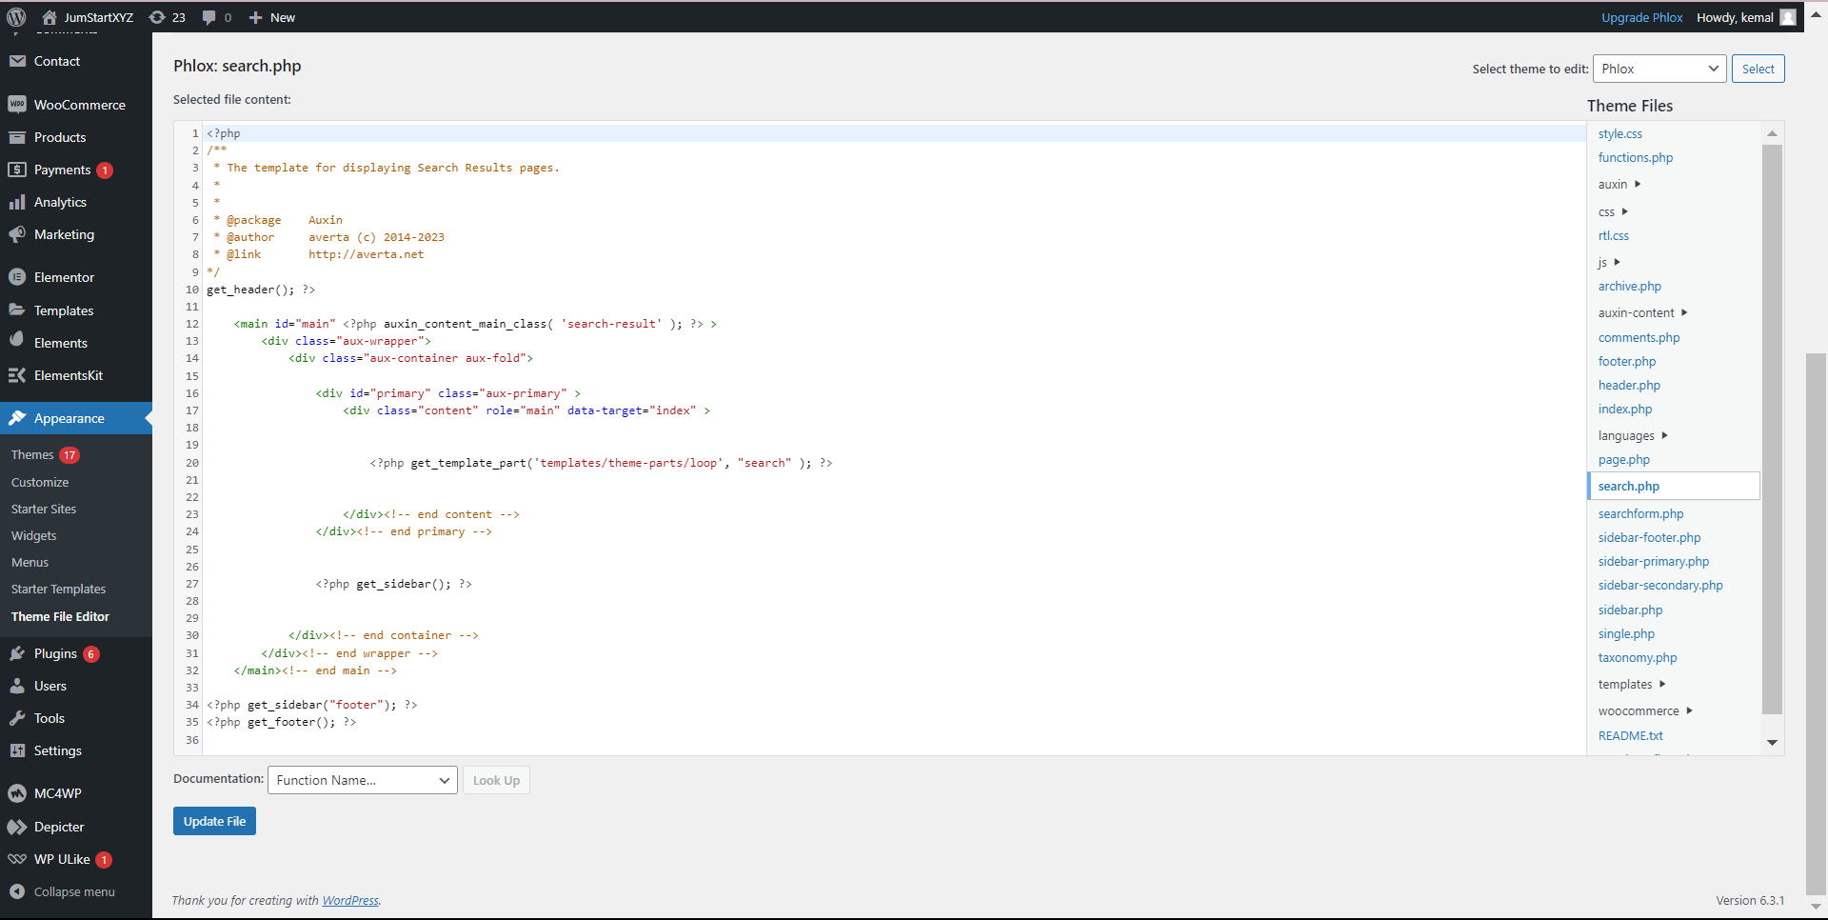

1. **A detailed roadmap or timeline for the remaining tasks and deliverables, along with any changes or updates to the original project plan.**

Gantt Table

Progress While developing the Project